Time Stamp: Nov 14, 2021 – 17:48
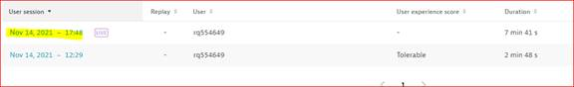
Below action event took ~9 seconds
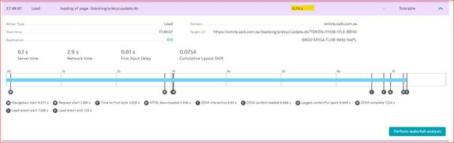
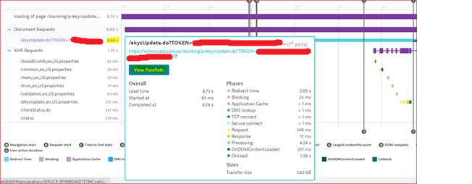
“View PurePath” the response time as measure on the server is 10.5ms.
