



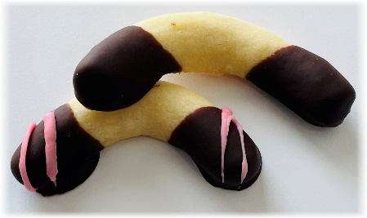
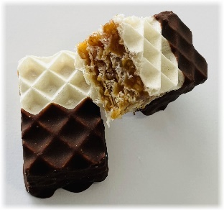
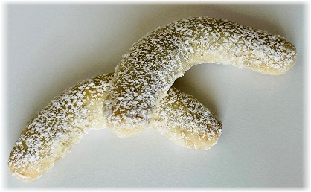
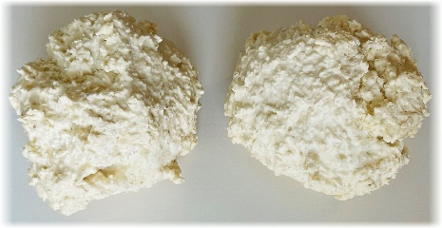
Gingerbread
Decorated Gingerbread
Walnut Cookies
Walnut cookie dough with apricot jam in the middle and topped with semisweet chocolate and a walnut.
Butter Cookies
Walnut Butter cookies with red raspberry jam and drizzled with semi-sweet chocolate.

Butter Cookies
Butter cookies with strawberry jam and sprinkled with powdered sugar.
Half-Dipped Rolls
Butter dough with both ends dipped in semi-sweet chocolate.
Coconut Kisses
Egg white and coconut wonder.
Vanilla Rolls
Walnut butter dough with a hint of lemon, rolled in vanilla and powdered sugar.
Caramel Wafers
Caramel and crushed walnuts sandwiched between multiple layers of wafers and half dipped in semi-sweet chocolate.

